<!DOCTYPE html>
<html lang="en">
<head>
<meta charset="UTF-8">
<meta name="viewport" content="width=device-width, initial-scale=1.0">
<title>Dynamic Menu</title>
<style>
body {
margin: 0;
font-family: Arial, sans-serif;
}
nav {
background: #222;
padding: 15px;
color: white;
}
.menu-btn {
background: #008080;
color: white;
padding: 10px 15px;
border: none;
cursor: pointer;
border-radius: 5px;
}
.menu {
display: none;
background: #444;
margin-top: 10px;
width: 200px;
}
.menu.show { display: block; }
.menu a {
display: block;
color: white;
text-decoration: none;
padding: 12px;
}
.menu a:hover, .menu a:focus {
background: #008080;
}
#message {
padding: 20px;
}
</style>
</head>
<body>

<nav>
<h2>My Website</h2>
<button class="menu-btn" id="menuBtn"
aria-expanded="false" aria-controls="menu">
☰ Menu
</button>

<div class="menu" id="menu">
<a href="#home" data-page="Home">Home</a>
<a href="#about" data-page="About">About</a>
<a href="#services" data-page="Services">Services</a>
<a href="#contact" data-page="Contact">Contact</a>
</div>
</nav>

<div id="message">
<h2>Welcome!</h2>
<p>Click the menu button to see the options.</p>
</div>

<script>
const button = document.getElementById("menuBtn");
const menu = document.getElementById("menu");
const message = document.getElementById("message");

button.addEventListener("click", function() {
menu.classList.toggle("show");

const isOpen = menu.classList.contains("show");
button.setAttribute("aria-expanded", isOpen);
});

menu.addEventListener("click", function(event) {
if (event.target.tagName === "A") {
const page = event.target.dataset.page;

message.innerHTML = "<h2>" + page +
"</h2><p>You selected " + page + ".</p>";

menu.classList.remove("show");
button.setAttribute("aria-expanded", "false");
}
});
</script>

</body>
</html>

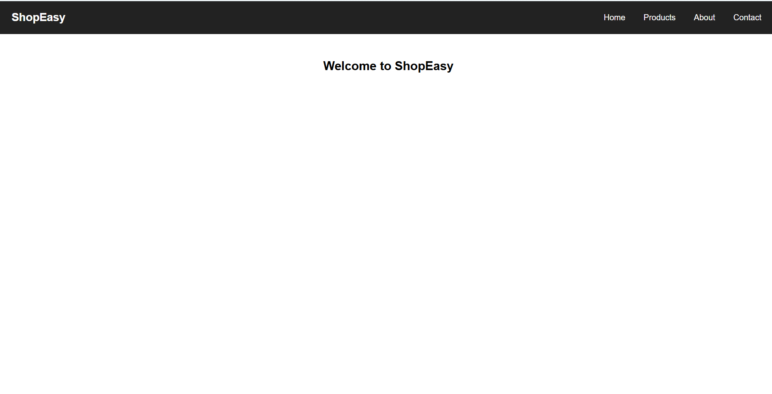

<!DOCTYPE html>
<html lang="en">
<head>
<meta charset="UTF-8">
<meta name="viewport" content="width=device-width, initial-scale=1.0">
<title>Dashboard Layout</title>
<style>
* { box-sizing: border-box; }
body {
margin: 0;
font-family: Arial, sans-serif;
background: #f4f6f9;
}
header {
background: #4834d4;
color: white;
padding: 20px;
}
.container {
display: grid;
grid-template-columns: 200px 1fr;
gap: 15px;
padding: 20px;
}
.sidebar, .card {
background: white;
padding: 20px;
border-radius: 8px;
}
.sidebar a {
display: block;
padding: 12px 0;
text-decoration: none;
color: #333;
}
.cards {
display: grid;
grid-template-columns: repeat(3, 1fr);
gap: 15px;
}
.card { box-shadow: 0 2px 5px #ddd; }
.card h3 { color: #4834d4; }

@media (max-width: 700px) {
.container { grid-template-columns: 1fr; }
.cards { grid-template-columns: 1fr; }
}
</style>
</head>
<body>
<header><h2>Student Dashboard</h2></header>
<div class="container">
<aside class="sidebar">
<h3>Menu</h3>
<a href="#">Home</a>
<a href="#">Courses</a>
<a href="#">Assignments</a>
<a href="#">Settings</a>
</aside>
<main>
<h2>Overview</h2>
<div class="cards">
<div class="card"><h3>Courses</h3><p>5 Active</p></div>
<div class="card"><h3>Assignments</h3><p>3 Pending</p></div>
<div class="card"><h3>Progress</h3><p>80%</p></div>
</div>
</main>
</div>
</body>
</html>
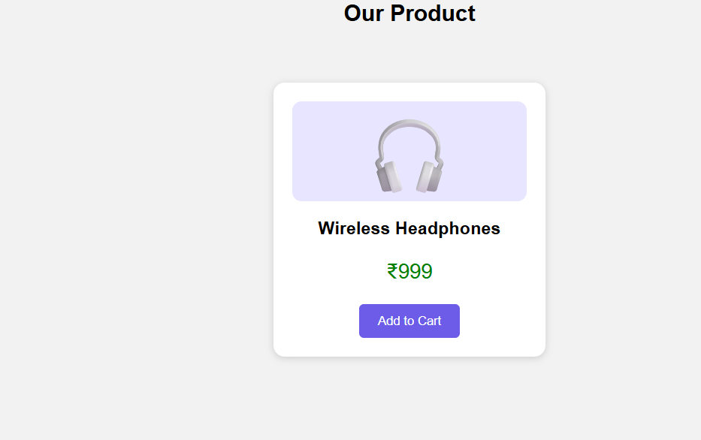

<!DOCTYPE html>
<html lang="en">
<head>
<meta charset="UTF-8">
<meta name="viewport" content="width=device-width, initial-scale=1.0">
<title>Dashboard Layout</title>
<style>
* { box-sizing: border-box; }
body {
margin: 0;
font-family: Arial, sans-serif;
background: #f4f6f9;
}
header {
background: #4834d4;
color: white;
padding: 20px;
}
.container {
display: grid;
grid-template-columns: 200px 1fr;
gap: 15px;
padding: 20px;
}
.sidebar, .card {
background: white;
padding: 20px;
border-radius: 8px;
}
.sidebar a {
display: block;
padding: 12px 0;
text-decoration: none;
color: #333;
}
.cards {
display: grid;
grid-template-columns: repeat(3, 1fr);
gap: 15px;
}
.card { box-shadow: 0 2px 5px #ddd; }
.card h3 { color: #4834d4; }

@media (max-width: 700px) {
.container { grid-template-columns: 1fr; }
.cards { grid-template-columns: 1fr; }
}
</style>
</head>
<body>
<header><h2>Student Dashboard</h2></header>
<div class="container">
<aside class="sidebar">
<h3>Menu</h3>
<a href="#">Home</a>
<a href="#">Courses</a>
<a href="#">Assignments</a>
<a href="#">Settings</a>
</aside>
<main>
<h2>Overview</h2>
<div class="cards">
<div class="card"><h3>Courses</h3><p>5 Active</p></div>
<div class="card"><h3>Assignments</h3><p>3 Pending</p></div>
<div class="card"><h3>Progress</h3><p>80%</p></div>
</div>
</main>
</div>
</body>
</html>
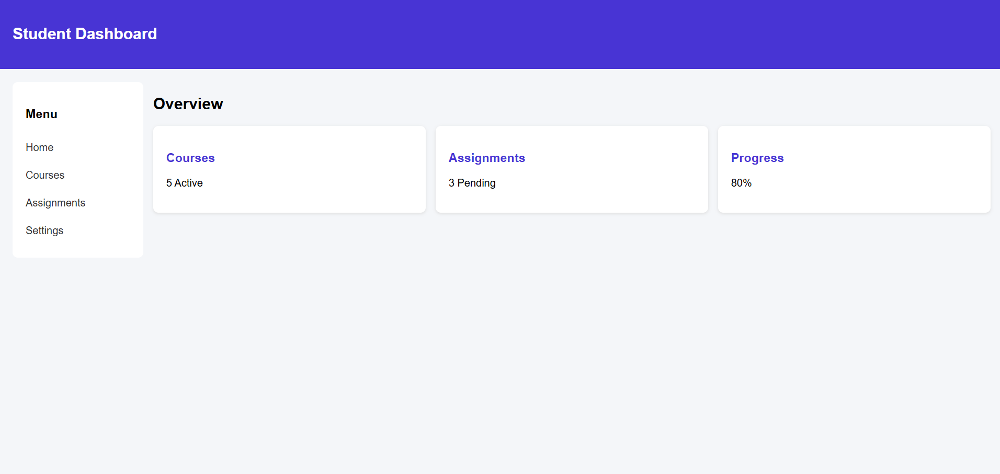

<!DOCTYPE html>
<html lang="en">
<head>
<meta charset="UTF-8">
<meta name="viewport" content="width=device-width, initial-scale=1.0">
<title>My Blog</title>
<style>
* { box-sizing: border-box; }
body {
margin: 0;
font-family: Arial, sans-serif;
line-height: 1.6;
background: #f9f9f9;
color: #333;
}
header {
background: #008080;
color: white;
padding: 20px;
text-align: center;
}
nav {
background: #222;
padding: 12px;
text-align: center;
}
nav a {
color: white;
text-decoration: none;
margin: 10px;
}
.container {
padding: 15px;
max-width: 1000px;
margin: auto;
}
article, aside {
background: white;
padding: 18px;
margin-bottom: 15px;
border-radius: 8px;
}
article h2 { color: #008080; }
footer {
text-align: center;
background: #222;
color: white;
padding: 15px;
}
/* Larger screens */
@media (min-width: 768px) {
.container {
display: grid;
grid-template-columns: 2fr 1fr;
gap: 20px;
}
}
a:focus {
outline: 3px solid orange;
}
</style>
</head>
<body>
<header>
<h1>My Blog</h1>
<p>Ideas, Stories and Technology</p>
</header>

<nav>
<a href="#">Home</a>
<a href="#">Articles</a>
<a href="#">About</a>
</nav>

<div class="container">
<main>
<article>
<h2>Benefits of Technology</h2>
<p>Technology makes our daily life easier and faster.
It helps us communicate, learn and solve problems.</p>
<a href="#">Read More</a>
</article>
<article>
<h2>Healthy Lifestyle</h2>
<p>A healthy lifestyle includes good food, regular
exercise, proper sleep and a positive mindset.</p>
<a href="#">Read More</a>
</article>
</main>

<aside>
<h2>About Me</h2>
<p>Welcome to my blog! I share useful ideas and stories.</p>
<h3>Categories</h3>
<p>Technology</p>
<p>Education</p>
<p>Lifestyle</p>
</aside>
</div>

<footer>
<p>© 2026 My Blog</p>
</footer>
</body>
</html>
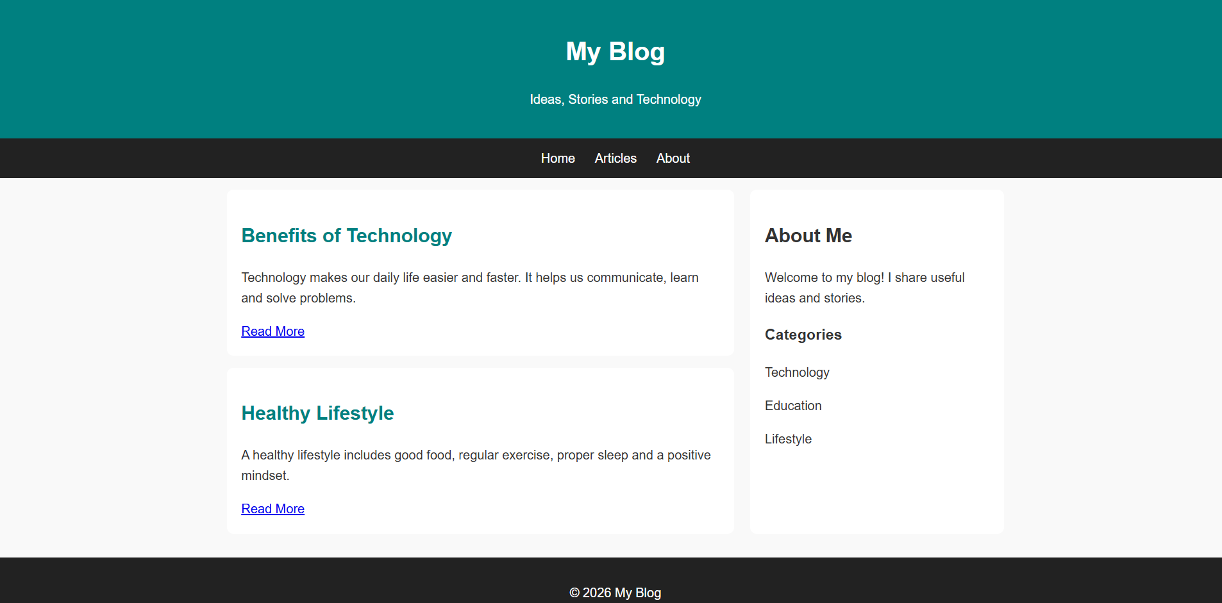

<!DOCTYPE html>
<html lang="en">
<head>
<meta charset="UTF-8">
<meta name="viewport" content="width=device-width, initial-scale=1.0">
<title>Dynamic Menu</title>
<style>
body {
margin: 0;
font-family: Arial, sans-serif;
}
nav {
background: #222;
padding: 15px;
color: white;
}
.menu-btn {
background: #008080;
color: white;
padding: 10px 15px;
border: none;
cursor: pointer;
border-radius: 5px;
}
.menu {
display: none;
background: #444;
margin-top: 10px;
width: 200px;
}
.menu.show { display: block; }
.menu a {
display: block;
color: white;
text-decoration: none;
padding: 12px;
}
.menu a:hover, .menu a:focus {
background: #008080;
}
#message {
padding: 20px;
}
</style>
</head>
<body>

<nav>
<h2>My Website</h2>
<button class="menu-btn" id="menuBtn"
aria-expanded="false" aria-controls="menu">
☰ Menu
</button>

<div class="menu" id="menu">
<a href="#home" data-page="Home">Home</a>
<a href="#about" data-page="About">About</a>
<a href="#services" data-page="Services">Services</a>
<a href="#contact" data-page="Contact">Contact</a>
</div>
</nav>

<div id="message">
<h2>Welcome!</h2>
<p>Click the menu button to see the options.</p>
</div>

<script>
const button = document.getElementById("menuBtn");
const menu = document.getElementById("menu");
const message = document.getElementById("message");

button.addEventListener("click", function() {
menu.classList.toggle("show");

const isOpen = menu.classList.contains("show");
button.setAttribute("aria-expanded", isOpen);
});

menu.addEventListener("click", function(event) {
if (event.target.tagName === "A") {
const page = event.target.dataset.page;

message.innerHTML = "<h2>" + page +
"</h2><p>You selected " + page + ".</p>";

menu.classList.remove("show");
button.setAttribute("aria-expanded", "false");
}
});
</script>

</body>
</html>
